Collect:  Almighty and ever-living God, clothed in majesty, whose beloved Son was this day presented in the Temple, in substance of our flesh: grant that we may be presented to you with pure and clean hearts, by your Son Jesus Christ our Lord, who is alive and reigns with you, in the unity of the Holy Spirit, one God, now and for ever. Amen.  Post Communion:  Lord, you fulfilled the hope of Simeon and Anna, who lived to welcome the Messiah: may we, who have received these gifts beyond words, prepare to meet Jesus Christ when he comes to bring us eternal life; for he is alive and reigns, now and for ever. Amen. | 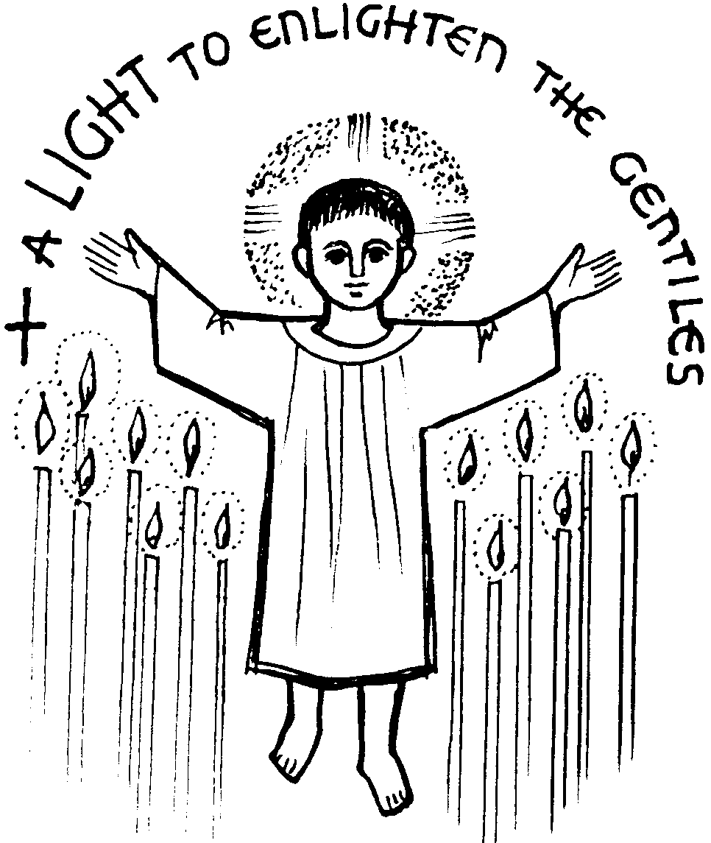  Sunday January 31st 2021  CANDLEMAS  THIS WEEK AT  HOLY CROSS, WOODCHURCH  Sunday 31st January 2021  8am – NO SERVICE IN CHURCH  10am Morning service on Zoom  Welcome to Holy Cross Church.  “Growing disciples of Christ”
READINGS FOR TODAY:
First Reading – Malachi 3. 1-5
See, I am sending my messenger to prepare the way before me, and the Lord whom you seek will suddenly come to his temple. The messenger of the covenant in whom you delight—indeed, he is coming, says the Lord of hosts. But who can endure the day of his coming, and who can stand when he appears?
For he is like a refiner’s fire and like fullers’ soap; he will sit as a refiner and purifier of silver, and he will purify the descendants of Levi and refine them like gold and silver, until they present offerings to the Lord in righteousness. Then the offering of Judah and Jerusalem will be pleasing to the Lord as in the days of old and as in former years.
Then I will draw near to you for judgement; I will be swift to bear witness against the sorcerers, against the adulterers, against those who swear falsely, against those who oppress the hired workers in their wages, the widow, and the orphan, against those who thrust aside the alien, and do not fear me, says the Lord of hosts.
Psalm 24
The earth is the Lord’s and all that is in it, the world and all who dwell therein. For it is he who founded it upon the seas and make it firm upon the rivers of the deep. ‘Who can ascend the hill of the Lord? and who can stand in his holy place?’ ‘Those who have clean hands and a pure heart, who have not pledged themselves to falsehood, nor sworn by what is a fraud. They shall receive a blessing from the Lord and a just reward from the God of their salvation.’ Such is the generation of those who seek him, of those who seek your face, O God of Jacob. Lift up your heads, O gates; lift them high, O everlasting doors; and the King of glory shall come in. ‘Who is this King of glory?’ ‘The Lord, strong and mighty, the Lord, mighty in battle.’ Lift up yout heads, O gates; lift them high, O everlasting doors; and the King of glory shall come in. ‘Who is he, this King of glory?’ ‘The Lord of hosts, he is the King of glory.’
Second Reading – Hebrews 2. 14-18
Since, therefore, the children share flesh and blood, he himself likewise shared the same things, so that through death he might destroy the one who has the power of death, that is, the devil, and free those who all their lives were held in slavery by the fear of death. For it is clear that he did not come to help angels, but the descendants of Abraham. Therefore he had to become like his brothers and sisters in every respect, so that he might be a merciful and faithful high priest in the service of God, to make a sacrifice of atonement for the sins of the people. Because he himself was tested by what he suffered, he is able to help those who are being tested.
Gospel – Luke 2. 22-40
When the time came for their purification according to the law of Moses, they brought him up to Jerusalem to present him to the Lord (as it is written in the law of the Lord, ‘Every firstborn male shall be designated as holy to the Lord’), and they offered a sacrifice according to what is stated in the law of the Lord, ‘a pair of turtle-doves or two young pigeons.’
Now there was a man in Jerusalem whose name was Simeon; this man was righteous and devout, looking forward to the consolation of Israel, and the Holy Spirit rested on him. It had been revealed to him by the Holy Spirit that he would not see death before he had seen the Lord’s Messiah. Guided by the Spirit, Simeon came into the temple; and when the parents brought in the child Jesus, to do for him what was customary under the law, Simeon took him in his arms and praised God, saying,
‘Master, now you are dismissing your servant in peace, according to your word;
for my eyes have seen your salvation, which you have prepared in the presence of all peoples, a light for revelation to the Gentiles and for glory to your people Israel.’
And the child’s father and mother were amazed at what was being said about him. Then Simeon blessed them and said to his mother Mary, ‘This child is destined for the falling and the rising of many in Israel, and to be a sign that will be opposed so that the inner thoughts of many will be revealed—and a sword will pierce your own soul too.’
There was also a prophet, Anna^{[j]} the daughter of Phanuel, of the tribe of Asher. She was of a great age, having lived with her husband for seven years after her marriage, then as a widow to the age of eighty-four. She never left the temple but worshipped there with fasting and prayer night and day. At that moment she came, and began to praise God and to speak about the child to all who were looking for the redemption of Jerusalem.
When they had finished everything required by the law of the Lord, they returned to Galilee, to their own town of Nazareth. The child grew and became strong, filled with wisdom; and the favour of God was upon him.

In your intercessions this week
PLEASE PRAY FOR:
THOSE WHO LIVE AND WORK IN:
Sunday: Leeswood Road Monday: Linden Drive
Tuesday: Lower Green Wednesday: Maritime Court
Thursday: Mavis Drive Friday: Meadow Crescent
Saturday: Merton Drive

Please pray especially for all who are affected by the coronavirus outbreak, especially those in isolation and all who care for them and for all who work in and for the National Health Service together with all other key workers.

THOSE WHO ARE ILL:  Jeanette, Colin, Pat, Anne, Pauline, Kath, Ilaria, Ann, David, Shirley, Mary, Mavis, Kenny, Di, Heather, John, Beryl, Brian, Jayne, Christopher, Maureen, Emma, John, Duncan, John, Margaret, Neil, Carol, Chris  Names from this list are normally transferred to the monthly prayer list after a few weeks | YEARS MIND:  Lilian Briton, Lorraine Johns.
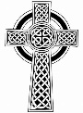
THOSE WHO HAVE DIED:
Emily Doreen Roberts

"Give rest O Christ to your servants with the saints, where sorrow and pain are no more, neither sighing but life everlasting. Amen"
THE WEEK AHEAD

Tuesday 2nd February 8.00pm – Bible Study this week via Zoom
Sunday 7th February 10.00am – Sunday Service via Zoom

BIBLE READING FOR THE WEEK:
CANDLEMAS - Luke 2:22-40
Mary and Joseph followed the social custom and religious duty. Being a Jewish family, this would be lived-out by daily telling bible stories and by prayers together. Two old people realised what God would do through this baby Jesus. What a day!
Prayer: Lord, we offer to you the rising generation. We pray that they will discover for themselves a living faith in Jesus

Please see our Website (www.holycrosswoodchurch.uk) and Facebook page (Holy Cross Church Woodchurch-Approved) for further information regarding the life of this worshipping community. The Rector of this church can be contacted in an emergency by telephoning 0151 677 5352 (Parish Office) or 07766 031757 or emailing parishoffice@holycrosswoodchurch.uk Or Christine.broad@holycrosswoodchurch.uk
For further information please see our website
www.holycrosswoodchurch.uk
or email: parishoffice@holycrosswoodchurch.uk
or call Parish office: 0151 677 5352
or Rector: 07766 031757
Find us on Facebook! - Holy Cross Church Woodchurch- Approved

Our verse for the year
“… and hope does not disappoint us, because God’s love has been poured into our hearts through the Holy Spirit that has been given to us”
(Romans 5.5)
Sue Mountford, Reader in Training – thoughts on this verse:
Even though we’re in and out of hope at the moment we know that if we continue to reach out for God, we will know we are not stuck. God’s hope is always there for us through the Holy Spirit.

Pastoral Care at Holy Cross
To enable us to initiate and co-ordinate our responses to all pastoral needs as speedily as possible, please get in touch with one of our Pastoral Workers, Paul Jackson (648 4291) or Jan Lupton (07835 063466) or the Parish Office on 0151 677 5352, or email at parishoffice@holycrosswoodchurch.uk

Covid-19 Update
Regular Services in Church have been temporarily suspended due to the rapidly rising incidence of coronavirus infection
on the Wirral
Services Online continue via Zoom/Facebook/Youtube and also via telephone
Sundays 10am Morning service- Zoom/Facebook
For further information / Zoom code for this week/information re groups and bible study please contact the parish office on
0151 677 5352 or email parishoffice@holycrosswoodchurch.uk
Or visit the website www.holycrosswoodchurch.uk

NOTICES

Bible Study - We meet on Tuesdays from 8pm to 9.15pm on Zoom and you would be very welcome to join us. Please contact Rev Josie on josie.tuplin@holycrosswoodchurch.uk for the Zoom link if you would like to be part.

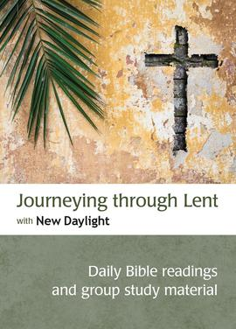
LOOKING AHEAD TO LENT
This Lent, why not take up something new instead of (or as well as) giving something up? The Bible Reading Fellowship has produced an excellent booklet with a short Bible reading, reflection and prayer for every day from Ash Wednesday to Easter Day. Contributors include the new Archbishop of York, Stephen Cottrell.

If you would like to have a copy for your Lent reading, we can order one for you. Alternatively, you can order direct BRF yourself. The cost (not including postage) is £2.99.

In addition, if you have access to the internet, the Zoom Bible Study group will be looking at some of these daily readings on Tuesday Evenings throughout Lent at 8pm, and all are very welcome.

If you would like us to order a copy for you, please contact Revd Josie by January 31st on 07592721399 (by text if possible). Please give your name, number of copies required and contact details. We will then contact you to let you know the precise cost and arrange delivery.

100 Club Membership (Advance Notice): Thank you for supporting the 100 Club and supporting our church. To renew your membership for members who have paid £60 annually this is now due to enable you to be included in the draw for March. Please could you post your cheque to the Parish Office or phone the office for our bank details.

Celebration Greetings: Does anyone have a special birthday or anniversary coming up? As we are unable to gather in the hall to celebrate special occasions at the moment, if you would like a greeting to be added to the pew sheet for such an occasion please let the parish office know at least a week in advance of the occasion and we will endeavour to include your request on the pew sheet.

NOTICES (cont’d)

Used Postage Stamps: Now is the time to save your stamps, untrimmed please, in aid of Hearing Dogs for the Deaf.
Thank you Gwyneth
Where’s Rosie?... there is a small picture of Sue’s dog somewhere on this pewsheet – can you find her?

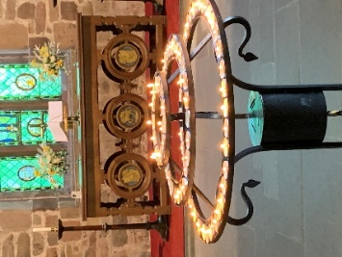
Lighting a candle. Although the church building is closed for public worship at the present time, our clergy are permitted to go into church to pray. If you have a particular prayer request for a particular situation or a person and would like us to light a candle in church for you at this time please text 07592 721399 or 07766031757 with your request and we will add our prayers to yours and light a candle for you when we are next in the church.

TELEPHONE WORSHIP DIRECT FROM HOLY CROSS
You can now listen to a recorded version of our Sunday morning worship by telephone. Dial (0151) 318 2533 at any time to join Revd Josie for 10 minutes of prayer and reflection. This is a local call on a landline. The charge is the same as any local call and is free if your phone package includes free calls at certain times of day. Please pass this information on to anyone you know who isn’t able to get to church or use the internet.
The Church of England’s “Daily Hope” telephone service is also still available free on 0800 804 8044.

Gwyneth’s Quiz – Reminder to return ASAP please.

A Message from the Rector for Candlemas 2021

The festival of Candlemas observed on 2nd February- or the nearest Sunday- each year is one of my very favourite festivals. Preparing the service for our forthcoming keeping of this festival I looked out of my study window this week to see quite a flurry of snow, quickly carpeting in pure white the Rectory garden and surrounding streets. Seeing snow around the time of the festival of Candlemas always takes me back in my imagination to my first keeping of Candlemas as a fairly newly ordained priest, now more than 13 years ago. The memory of that service still brings joy to my heart. Following the service, I reflected on the mystery of the events of the festival and would like to share those reflections today, I hope that you enjoy this reflection and that your own keeping of Candlemas will be blessed in 2021.

Candlemas in Burslem, Stoke on Trent. February 2008
“How appropriate to look out of the window to see the ground covered with a sprinkling of snow on the morning of February 2nd. Doesn’t a covering of snow make even the most ordinary of landscapes look so clean, bright and beautiful? The dullest of streets is transformed by a few flakes of frozen water into a bright white, somehow more interesting place. And doesn’t it look so, well, Christmassy? Which is why a little snow on February 2nd seemed so appropriate as 40 days after celebrating His birth, we recalled the presentation of the infant Christ in the temple at Jerusalem- the feast of Candlemas - the closing celebration, if you like, of the Christmas season.

Ancient words sung to a haunting melody as we processed, holding lit candles, into church assisted our recalling of the words of the Spirit filled Simeon, “A light to lighten the gentiles and the glory of thy people Israel.” And the twinkling lights illuminating the crib- now immanently to be placed in storage until Christmas celebrations begin again for 2008- drew our attention once more to the infant Christ, for he is the one who is that light of which Simeon wrote and of whom we sing.

As we sang festive carols and liturgies, which like the crib would soon be put away until next Christmas, the snow outside was melting fast, and the streets were returning to their less than polished look. A covering of snow does much for outward appearance- but that which is underneath remains unchanged of course.

How tragic it would be if we allowed this to be so for our celebrations of the incarnation of the light of the world- if when the last decorations were put away and the last candle blown out we were to find that we had failed to connect to the one for whom the celebrations had taken place and discover that we ourselves were unchanged on the inside by our encounter with Jesus.

John tells us that “the light shines in the darkness and the darkness can never extinguish it” (John 1 v 5). Christmas and Candlemas may be behind us now, for this year!- but if we invite Christ to shine his light in our lives every day, then we can carry that light, and the joy and peace with which the light is accompanied, with us all the time, whatever the season! Amen”

Still true I believe in 2021, the light is indeed still shining in the darkness!

As we turn our focus from the crib to the cross this week and begin to prepare for Lent may God bless you and keep you as you walk in the light of Christ.

With love in Christ,
Christine

